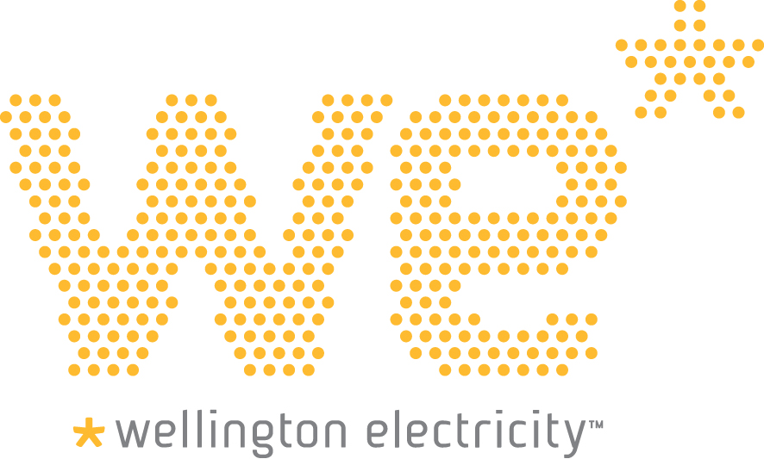

Warning: Printed copies of this document not in an official Manual MAY NOT BE THE LATEST. The most up-to-date version is located on the Intranet.

Congestion, Curtailment and Interruption Management Policy

- Introduction

This policy explains the concepts of congestion and curtailment in the context of the connection of distributed generation (DG) to the Wellington Electricity distribution network (the network). It describes the company’s approach to congestion, curtailment, and interruption and disconnection requirements. This is applicable where DG is being used to export electricity to the network.

Wellington Electricity provides electricity lines function services to consumers via its network within the Wellington region. The network is mainly engineered around electricity flowing in one direction (network to customer). Small scale generation commonly referred to as distributed generation is increasingly being installed by individual customers for various reasons, primarily to reduce the quantity of electrical energy required from the network on an overall basis, hence reducing energy costs but not alleviating the need for network capacity or necessarily contributing to a reduction in network peak demand. This can lead to relatively significant amounts of electricity being exported from aggregated distributed customer generation to the network.

Congestion

Congestion occurs when the reversed power flow caused by the exported electricity being injected into the network results in a network asset or circuit operating beyond its rated maximum capacity, or an unacceptably high voltage level occurring on localised sections of the network (low voltage as well as high voltage circuits) at certain times of the day.

The potential impacts of such congestion include: reduced network flexibility, security and safety; equipment damage and associated costs; and power quality and fault level issues. DG connection criteria therefore need to be carefully managed to ensure that the aforementioned adverse impacts do not occur.

Part 6 of the Electricity Industry Participation Code 2010 (the Code) governs the connection of distributed generation to ensure that the operation of New Zealand’s electricity grid remains stable and reliable. The Code aims to encourage cost effective generation, particularly using renewable fuel sources such as solar photovoltaic panels. Wellington Electricity welcomes the connection of distributed generation to its network providing technical and regulatory requirements are met so there is no impact to other customers, and the ability to operate our network safely and sustainably is not compromised.

Curtailment

Curtailment is dispatch below maximum output. It is a reduction in the output of a generator from what it could otherwise produce given available resources (e.g., wind or sunlight), usually on an involuntary basis. Curtailments can result when operators or utilities require distributed generators to reduce output to minimise localised network congestion.

Interruptions and Disconnections

Clause 10 of Schedule 6.2 of the Code requires Wellington Electricity to make reasonable endeavours to ensure that the connection of the DG is not interrupted, but Clause 11 permits such interruption or curtailment of the DG in a number of cases, including the need to comply with the requirements listed in Section 2 of this policy.

To protect the network from islanding, the DG’s protection systems are required to disconnect the DG from the network, whenever the supply from the network is disrupted or when the grid goes outside set voltage and frequency parameters. Passive and active anti-islanding protection is required for customers installing and operating DG connected to the network.

- Conditions
The following specifies the conditions under which distributed generation electrical output may need to be curtailed or disconnected from the network:
- Operation of the DG presents a danger to personnel working on the network, or risk to property.
- Output from the DG causes the network to exceed voltage limits set by the Electricity (Safety) Regulations 2010, clause 28.
- Output from the DG exceeds the rating of connected equipment (i.e. the capacity of the network components to which it is connected).
- Operation of the DG causes a disruption in the supply to other customers (e.g. power quality issues under certain operational conditions e.g. excessive voltage fluctuations or harmonics).
- If reasonably necessary for planned maintenance, construction and repairs on the distribution network

- Congestion Management Process
There are two main ways to manage network congestion:
- By ensuring that the distributed generation connection only occurs in unconstrained areas or is accompanied by an appropriate network upgrade
- By agreeing the operational rules that will apply on a case-specific basis
During Application:
Wellington Electricity will review all DG applications (including both new installations, as well as change in the nameplate capacity or fuel type of an existing installation), and identify situations where connection of the applicant’s DG may compromise the security of the relevant part of the network, or create any safety concerns. If Wellington Electricity deems as part of the assessment, the connection of the proposed DG meets the Conditions for curtailment or disconnection as set out in Section 2 above, Wellington Electricity may offer assistance to the applicant to help them comply. If the proposed DG installation still meets the Conditions for curtailment or disconnection, the application to connect to the network for exporting purposes may be declined with an associated explanation.
Where the application is declined, the applicant can still resubmit a revised application that addresses the reasons for declining the original application.

In cases where DG installations greater than 10kW would create congestion issues, these could be mitigated by reinforcement of the network to which the DG is being connected. In such circumstances, the costs and timing of such reinforcement would need to be factored into the DG installation planning.

During Operations:

If Wellington Electricity approves the distributed generator’s application, the regulated terms for the connection of the DG as set out in Schedule 6.2 of Part 6 of the Code apply, unless alternative terms are mutually agreed.
For DG installations less than 10kW to be approved for connection, they must adhere to Wellington Electricity’s technical standards as specified in Document no: ENG-101 (available on the company’s website on the ‘Getting Connected’ page). This includes the Disconnection requirements referred to in Section 1.
DG installations greater than 10kW must adhere to Wellington Electricity’s technical standards as specified in Document no: ENG-102 (available on the company’s website on the ‘Getting Connected’ page). The distributed generation will be disconnected automatically by the installation’s protection settings, unless alternative options such as curtailment have been previously agreed.
Reconnection of the distributed generation is permissible on clearance of the congestion or disturbance conditions.
- Current and Future Situations

Current Situation

For any new DG installations of 10kW or less, Wellington Electricity does not expect congestion to be an issue in the foreseeable future (next 12 to 18 months until mid to late 2016) but will monitor this, and has developed this policy to deal with potential future situations.

Using the database of DG installations and network capacity models, assessments will be done to determine the areas of the network that would be congested with the addition of future DG.

For installation requests of more than 10kW, individual assessments will need to be undertaken by Wellington Electricity to determine whether congestion could occur.
Future Situation
Changing network conditions may result in previously accepted DG applications creating subsequent issues on the network of the type described in Section 2 above. Under these circumstances Wellington Electricity may require the DG operator to curtail or disconnect their operation of the distributed generation to reduce output, operate within nominated times or conditions, or both.

The curtailment may be applied to any or all of the DG operators on the part of the network experiencing the Conditions.

The congestion management measure taken will be dependent on the extent of congestion, technical and operational characteristics, and connection terms and condition.

In the case of any larger scale DG connected to the network where operational agreements are in place, these will factor into any future congestion management actions taken by Wellington Electricity.

END OF DOCUMENT

